**Key questions - 6 Lessons:** Who are our leaders? What qualities do leaders have? What were the events of Palm Sunday? What is the Easter story? Do you think we should follow Jesus? How can we show our beliefs through Art?

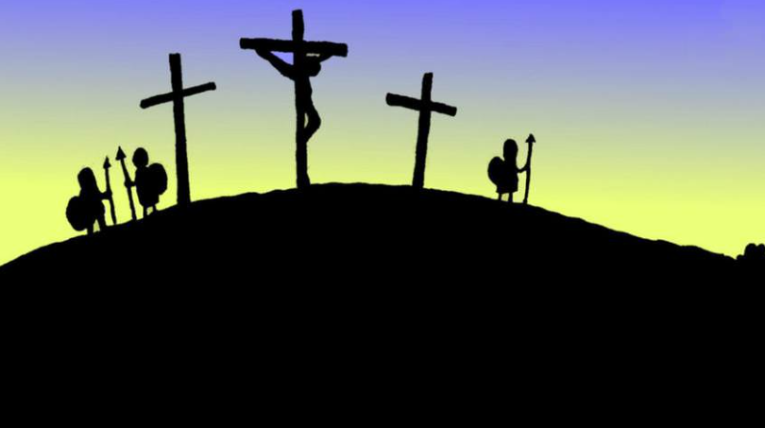

**I should be able to…**

* Discuss the need for leaders.
* Describe what makes a good leader.
* Retell a story about Jesus.
* Retell and sequence the Easter story.
* Identify what makes Jesus a leader.

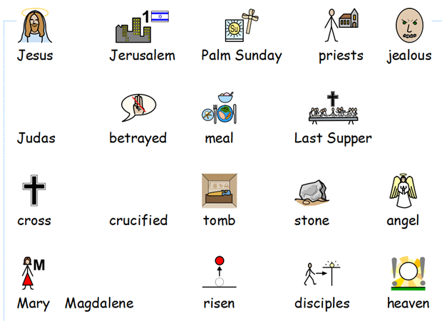

**I can…**

1. I can identify who different leaders are and who or what they lead.
2. I can explain what qualities leaders have.
3. I can act out the story and events of Palm Sunday.
4. I can sequence the Easter story to retell it through pictures.
5. I can reflect on what makes Jesus a good leader and if we should follow him.
6. I can create a piece of Easter art.