
St Mary’s Farnham Royal
Term: Spring 1 Year: 5 Teachers: Mr Copete, Miss Clayton, Mr Farmer and Mrs Hay
PE and Music objectives can be found on the subject pages for PE and Music on our school website
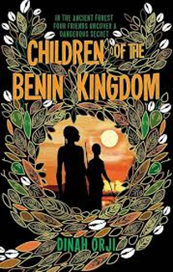

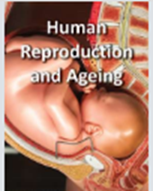

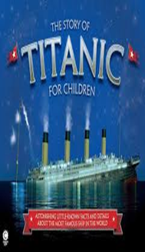
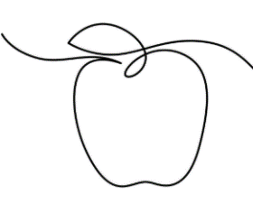
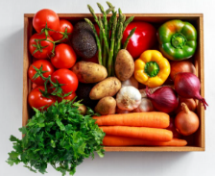


Reading:
Over the next three weeks, the children will be reading ‘The story of the Titanic for children’. An amazing information text that leads the children through the history of the Titanic and its fateful journey. They will learn about it’s construction, the fateful prophecies about its doom, the people on board and how the terrible disaster occurred. They will be using their skills of elicitation, retrieval, comparing information in texts and understanding word chooses. The children are really enjoying this text and it would be great if you did extra research with them around the titanic, In addition, hearing your children read aloud at least twice a week and having them recall what they have read and explain what has happened and why they think that is will really help with the skills they are learning.
Writing:
Over the next three weeks, the children will be studying the book, ‘Children of the Benin Kingdom’ by Dinah Orji. This book will inspire the children to plan, draft, edit and finally publish their own information text inf the Benin Kingdom. They will have an opportunity to write in character and empathise with the feelings and emotions the characters are experiencing. They will be writing diary entries, predictions and summaries each with a different SPaG focus. You could help by discussing the book with your children and what they have read and learned.
Geography:
Over the next three weeks, the children will learn about the characteristics and features of rivers and mountain ranges around the world, including a detailed exploration of the ecosystems and processes that shape them and the land around them. At home you could help by talking with your child about rivers, erosion, transportation and deposition as well as the water cycle. You could also talk about mountains of the world and contour lines, showing them pictures online or in books.
RE:
Over the next three weeks, the children will be investigating the first part of our big question, ‘Why is Muhammad known as the Seal of Prophets?’ This topic will help the children to learn more about Islam and identify key connections between this and other religions such as Judaism and Christianity. The children will learn about some key Abrahamic Prophets investigate what a seal is and why this is used to describe Muhammad and begin to understand the origin and main teachings of Hadith.
DT:
Our Spring DT topic is called ‘Eat the Seasons’ and over the next 3 weeks the children will be investigating seasonal produce, tasting this and making a vegan leek and potato soup. The topic is taught alongside the Geography topic Sow, Grow and Farm which looks at how food is produced and linked to seasons of the year.
This may be a great opportunity for you all to try some new seasonal fruits and vegetables or make soups of your own at home.
Art:
Over the next 3 weeks the children are continuing to build on their art skills, techniques and knowledge by looking at continuous single line drawings. They will investigate this technique for themselves, look at significant artists who have used this – such as Pablo Picasso – and create their own interpretations of the work they have studied. You may want to investigate continuous single line drawings with your child at home?
Science:
Over the next three weeks, children will learn about solids, liquids and gases and their characteristic properties. The children will observe how materials change state as they are heated and cooled, and learn key terminology associated with these processes. You could help your child by carrying out experiments changing states of matter, showing them how water turns to ice, chocolate melts etc.
Maths:
Over the next three weeks, the children will be focusing on multiplication and division, being able to multiply and divide by 10, 100 and 1000, understanding where and why the digits move before focusing on multiplying and dividing 2 and 3-digit numbers by a 1-digit number using an appropriate method. We will then be focusing on Length and Perimeter. Children will learn how to find the perimeter of regular and irregular shapes and find missing lengths, and converting measures. You could help your child at home by allowing your child to show you and talk through where the digits move using a place value chart and the column method for multiplying a number by a 1-digit number.

