
St Mary’s Farnham Royal
Term: Spring 1 Year: 4 Teachers: Miss Bailey, Mrs Birch, Miss Wilkinson
PE and music objectives can be found on the subject pages for PE and music on our website
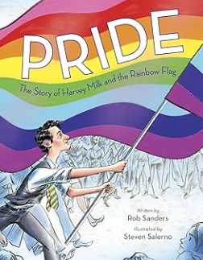

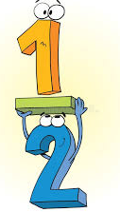

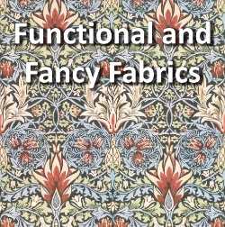

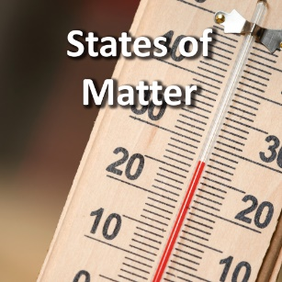

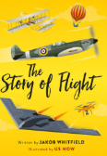
Maths:
Over the next three weeks, the children will be focusing on length and perimeter, finding the perimeter of rectangles and rectilinear shapes as well as finding missing lengths. They will then be learning about fractions, being able to understand the whole and mixed numbers. They will learn how to compare and order mixed numbers, understand improper fractions, convert fractions as well as add and subtract fractions and mixed numbers. You could help your child at home by allowing your child to show you and talk through what the whole is and the fraction is and let them show you how they calculate with fractions. You could watch clips together on how to convert fractions and add and subtract them.
Writing:
Over the next three weeks, the children will be studying the book: ‘Pride, The Story of Harvey Milk and the Rainbow Flag’ by Rob Sanders and Steven Salerno. This book will inspire the children to write leaflets, write speech for them to act in role and to create a biography of an activist’s life. You could help your child at home by talking about people through history that have fought for the rights of others. For example, Martin Luther King Jr, Nelson Mandela, Malala Yousafzai, Harvey Milk, Emmeline Pankhurst etc. You could share information about an activist and how they have helped society today.
RE:
Over the next three weeks, the children will be studying our big question, ‘What is the Trinity?’ They will understand the Trinity and how this is depicted in the story of Jesus’ baptism. The children will explore different extracts from the bible and the words used to describe God the Father and study art and poetry linked to the Trinity. They will also be able to make links between baptism, prayer and the Trinity. You could help your child at home by discussing the Trinity and watch clips on baptism. You could also talk about the relevance of not beginning and no end.

DT:
Over the next three weeks, children will learn about home furnishings and the significant designer William Morris. They will learn techniques for decorating fabric, including block printing, hemming and embroidery and use them to design and make a fabric sample. You could help your child at home by discussing the fabrics of different clothing items you have. You could even have your child sew different fabrics together that they could share with the class.
Art:
Over the next three weeks, children will be learning about the techniques that artists use when composing landscape images, such as colour and atmosphere. You could help your child at home by talking about the landscape you see outside your window, go on walks with your child and talk about the scenery. You could take a picture or choose a picture from an art book with landscapes and your child could recreate the scene using warm colours, techniques taught.
Science:
Over the next three weeks, children will learn about solids, liquids and gases and their characteristic properties. The children will observe how materials change state as they are heated and cooled, and learn key terminology associated with these processes. You could help your child by carrying out experiments changing states of matter, showing them how water turns to ice, chocolate melts etc.
Geography:
Over the next three weeks, the children will learn about the characteristics and features of rivers and mountain ranges around the world, including a detailed exploration of the ecosystems and processes that shape them and the land around them. At home you could help by talking with your child about rivers, erosion, transportation and deposition as well as the water cycle. You could also talk about mountains of the world and contour lines, showing them pictures online or in books.
Reading:
Over the next three weeks, the children will be reading ‘The Story of Flight’. A beautifully illustrated history of the iconic flying machines that have helped us soar through the skies. They will learn all about the earliest balloons and airships to the latest stealth jet and how each breakthrough laid the foundation for the next. They will discover how the social upheavals of the past 240 years influenced the flight path: two world wars, equality for women and the fight against climate change and begin to explore the incredible inventions that await us in the future. You could help your child at home by talking to your child about the history of flight, ask your child what they have remembered.

