
St Mary’s Farnham Royal
Term: Spring 2 Year: 4 Teachers: Miss Bailey, Mrs Birch, Miss Wilkinson
PE and music objectives can be found on the subject pages for PE and music on our website
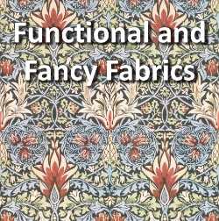
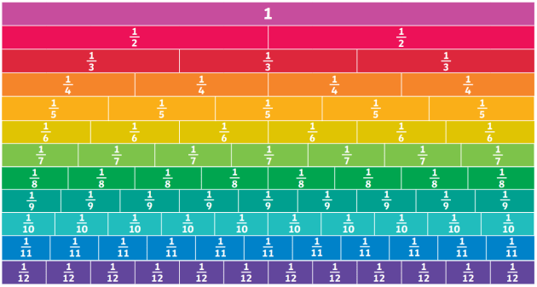

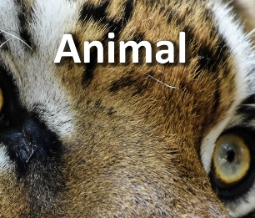

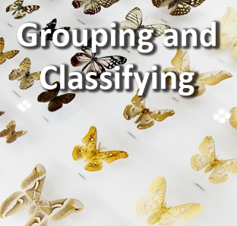
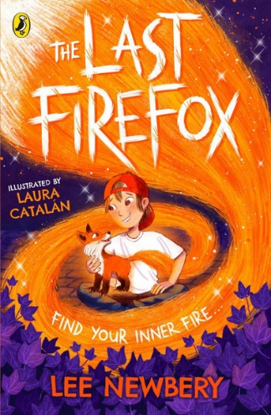
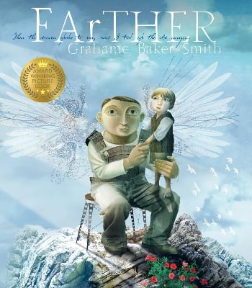
Pride
Science:
Over the next three weeks, children will learn about classification and how it is used. Children will compare, group and sort living things from a range of different environments. They will learn that invertebrates do not have a back bone and vertebrates do have a backbone. We will then look at what features vertebrates have and sort them according to these. You can help your child at home by talking about a range of animals and what group they belong to. Are they a vertebrate or invertebrate? Perhaps you could visit a wildlife park to see some of these animals in action.
DT:
To conclude our topic on Functional and Fancy Fabrics we will be learning how to sew a hem. Children will have a range of fabric designs to choose and will then use needles and thread to complete their work.
RE:
Over the next three weeks, the children will be studying our big question, ‘How do Hindus understand who God is?’ We will begin this by looking at symbols that are used to depict God and religion. We will then learn about different Hindu Gods and link this back to our learning of the Holy Trinity last term. We will continue this by moving onto looking at Hindu symbols and their meanings to introduce the different meanings behind the symbols and how they all represent qualities of the One God in the Hindu faith. You can help your child at home by spotting symbols when you’re out and about and discussing what these symbols represent.

Maths:
Over the next three weeks, the children will be focusing on fractions. Children begin this block by understanding the whole. Children will use diagrams to identify how many equal parts a shape has been split into and move on to thinking about how many more parts are needed to make the whole. We will be counting beyond 1 in fractions and using number lines with mixed numbers to compare and order. We will convert mixed numbers to improper fractions and look at equivalent fractions. We will find equivalent fractions by looking at fractions that are in line with each other. You can help your child at home by cutting up pizzas or cakes into equal parts and identifying what fraction they’ve been divided into. Can you also identify some equivalent fractions?
Geography:
Over the next three weeks, the children will be learning about topography and contour lines. They will be studying mountains of the UK and will create a mini fact-file about Ben Nevis or Scafell Pike. They will then move onto studying mountains and mountain ranges from around the world. You can help your child at home by looking at maps of the local area and talking about symbols and the ley on the maps and how different land height is shown.
Reading:
Over the next three weeks, the children will be reading ‘The Last Firefox’ by Lee Newbery. Children will follow Charlie and his new companion Cadno on a journey of bravery, friendship and discovery. They will make predictions about the characters and plot, make inferences about characters' behaviours and motivations and explore the impact of language choices on the reader. Through whole class and small group discussion, children will summarise key events and explore the themes arising within the text before writing a final review which could appear on the book cover. You can help your child at home by asking them to summarise a chapter they’ve read from their reading book.
Writing:
Over the next three weeks, the children will be studying the book: ‘FArTHER’ by Grahame Baker-Smith. This stunning picture book won the Kate Greenaway medal in 2011 and explores the relationship between a father and son. Close inspection of the text and illustrations provides subtle links to World War One and ancient Greece. We will begin by introducing the concept of dreams and how important they are in our lives. Children will work towards writing their own sequel of the story and a set of instructions to describe how their own flying machines will work. You could help your child by looking at different types of instructions at home and following some together, this could be a recipe or lego instructions for example.
Art:
This project teaches children about the historical and cultural portrayal of animals in art. They study the visual qualities of animals through sketching, printmaking and clay modelling. We will begin by sketching with pencil with a focus on animal pattern and texture. You can help your child at home by sketching an animal print or pattern and discussing the different types of animal skins and texture, e.g. comparing a tiger’s fur to a lizard’s scales.

