
St Mary’s Farnham Royal
Term: Spring 2 Year: 4 Teachers: Miss Bailey, Mrs Birch, Miss Wilkinson
PE and music objectives can be found on the subject pages for PE and music on our website
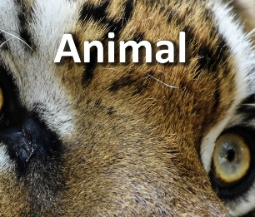

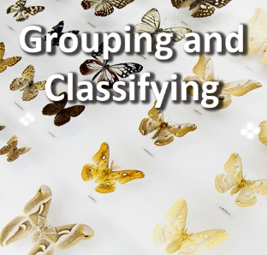
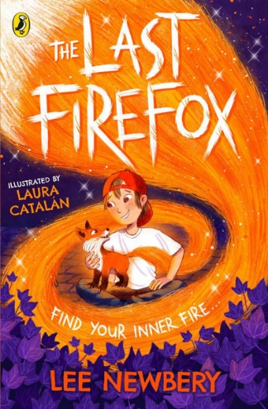

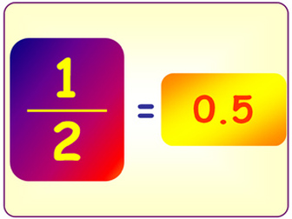
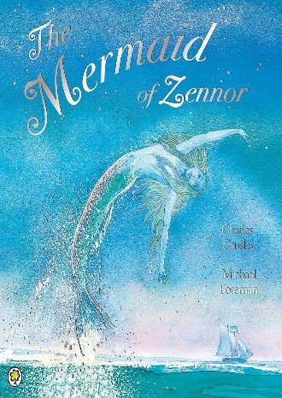
Pride
RE:
Over the next two weeks, the children will be concluding their work on our big question, ‘How do Hindus understand who God is?’ We will be focussing on the Creation Story, The Ganesha Story and The Krishna Story and drawing out what qualities of God each story shows. You could read stories from your religion or culture at home and think about what teaching they have.

Reading:
Over the next two weeks, the children will be continuing ‘The Last Firefox’ by Lee Newbery. We will be making comparisons in the text, for example characters, situations and settings. The children will also be thinking about how they would feel if they were in the same situation as the main character Charlie at different points in the text. You could help your child at home by asking them to make comparisons in the books that they are reading at home.
Art:
To finish this unit of work on animals the children will be block printing. We will be designing an outline of an animal and the children will manipulate pipe cleaners so they match their designs and will then use these for their printing. You could use materials from around your home to make your own printing tools- try cutting vegetables into different shapes or using materials from the recycling to create something exciting.
Science:
Over the next two weeks we will be using classification tables to sort invertebrates and looking at different arthropods and their characteristics (for example, arachnids have eight legs). Finally, we will study the plant kingdom, looking at the difference between vascular and non-vascular plants. You could help your child consolidate their learning about grouping and classifying in science by sorting plants and or animals that you see or find in your garden or on a walk using a classification table- you could even create your own classification table!
Geography:
Over the next two weeks, we will be concluding our unit of work on mountains and rivers. We will be looking at the water cycle and its four stages – evaporation, condensation, precipitation and collection – and how temperature changes drive the water cycle. Our final lesson will be about changing habitats. We will recap what a habitat is and what it must provide for living things and think specifically about mountainous habitats and their altitude with a focus on how a habitat at the bottom of a mountain would be very different to one at the top. You could set up your own evaporation investigation at home and report back your findings to us after the Easter holidays.
Writing:
Over the next two weeks, the children will be studying the book: ‘The Mermaid of Zennor’ by Charles Causley. This is themed around finding freedom and the children will be writing letters based on the book. The grammatical features we will focus on in this unit are: adverbials, prepositions and past tense. You could help your child at home by writing a letter to someone in your family and posting it- how exciting if the children were to receive a response back in the post!
Maths:
Over the next two weeks, the children will be finishing the unit on fractions and moving on to decimals. The learning we have done over this half term on fractions leads nicely into this decimals unit as children will be applying their existing fractions knowledge. They will begin by dividing 1-digit numbers by ten and then move on to dividing 2-digit numbers by 10. We will then be looking at tenths on a number line, writing them as fractions and then as decimals. You could help you child at home by asking them to match up fractions and decimals.

