Summer Term 2024 – important dates to remember

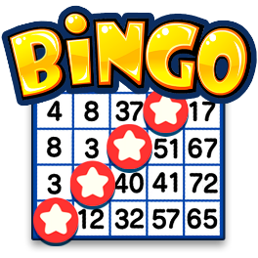
Friday 26th April
Family Bingo Night
Family Bingo fun at the FRCC from 6.00pm

Monday 6th May
After-school Clubs begin
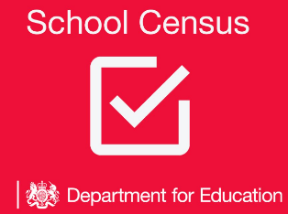
These are booked through the School Gateway

Thursday 16th May
School Census Day
This is a really important day for all children to be in school.

Monday 20th May to Friday 24th May
Copper Coin Challenge
Organised by the Friends of SMFR – details to follow


Monday 27th May – Friday 31st May
Summer Half Term – School closed
We will see you back on Tuesday 4th June


Tuesday 11th June
International Evening
An evening of Music and Culture-details to follow

Monday 1st July
Sports Day – Years 4, 5 and 6
Year 4, 5 & 6 parents are invited to join the children for Sports Day between 9.30am and 11.00am

Tuesday 2nd July
Sports Day – Reception & Nursery
EYFS parents are invited to join the children for Sports Day between 9.30am and 11.00am

Wednesday 3rd July
Sports Day – Years 1, 2 and 3
Year 1, 2 & 3 parents are invited to join the children for Sports Day between 9.30am and 11.00am


Week of 24th June
Last week of After-School Clubs
This will be the last week of Clubs. They will not be run over the last few weeks of term


Friday 28th June
SMFR Summer Fete
2.30pm to 5.00pm – details to be shared


Friday 5th July
Year 6 Leavers Disco
Year 6 children only. 6.00pm to 8.00pm

Monday 8th July – Friday 12th July
Year 6 Residential Week


Wednesday 17th July
Year 6 Production
Parents and families are invited to come and enjoy the show. 6.30pm

Tuesday 23rd July
Year 6 Leaver’s Service at St Mary’s Church
Year 6 Parents and Families are invited to St Mary’s Church at 9.15am


Tuesday 23rd July
School finishes for Summer holidays at 1.30pm. Have a great summer!

Term Dates & Dates Ahead

Monday 27th May 2024 School closed for Summer Half term week

Friday 23rd July 2024 School closes for Summer Holidays (1.30pm)

Thursday 5th September 2024 School opens for start of Autumn Term

Monday 28th October 2024 School closed for Autumn Half term week

Friday 20th December 2024 School closes for Christmas Holiday (1.30pm)

Tuesday 7th January 2025 School opens for start of Spring Term

Friday 14th February 2025 School closes for Spring Half-Term

Friday 4th April 2025 School opens for start of Summer Term

Friday 23rd May 2025 School closes for Summer Half-Term


Wednesday 23rd July 2025 School closes for Summer Holidays (1.30pm)

